**Bridging the Gulf of Alaska arrowtooth flounder assessment to CEATTLE**

The basis for the assessment is the climate-enhanced multi-species statistical catch-at-age analysis modelling framework developed for groundfish in the Bering Sea (Holsman et al., 2016) and expanded for groundfish in the GOA (Adams et al., 2022) using Template Model Builder (Kristensen et al., 2016). Developed in part from the underpinnings of multi-species statistical catch-at-age analysis (MSCAA, Jurado-Molina et al., 2005) and multi-species virtual population analysis (MSVPA; (Jurado-Molina et al., 2005; Magnusson, 1995), CEATTLE links single-species age-structured models (Table 1) through predation mortality conditioned on the temperature-dependent bioenergetic demand and diet-based prey-selectivity patterns of predators (Curti et al., 2013; Holsman et al., 2016; Kinzey and Punt, 2009). Predation mortality assumes a Holling Type II functional response and parameters are either pre-specified or estimated by fitting to survey and fishery data (Table 2). CEATTLE can be run in single-species mode by “turning-off” time-varying predation mortality or in multi-species mode by “turning-on” time-varying predation mortality. Within the context of arrowtooth flounder, cannibalism represents more than twice the amount of removals on average when compared to the fishery (Adams et al., 2022) and may have implications for harvest recommendations.

The goals of the bridging exercise are as follows:

* Update estimation of the arrowtooth flounder assessment using Template Model Builder.
* Understand the impacts of cannibalism on harvest recommendations.

**Data**

CEATTLE uses the same inputs as the single-species assessment model (SAFE model) used to provide management advice model in addition to diet and bioenergetics data (Adams et al., 2022). This includes: AFSC bottom trawl survey biomass estimates (catchability is assumed to be 1), fishery catch data, fishery age- and length-composition data, AFSC bottom trawl age-composition data, age-at-maturity, weight-at-age data, age-length transition matrix, and ageing error matrix. All data and assumed uncertainties are consistent with the SAFE model. Diet and bioenergetics data were derived from the AFSC stomach sampling program (Adams et al., 2022). Time-series of bottom temperature derived from the Climate Forecast System Reanalysis for the Pacific cod assessment was used (Hulson et al., 2023). Those data are used to parametrize consumption and diet composition.

**Model Structure**

For arrowtooth flounder in the GOA, CEATTLE spans 1977 to 2023 and is parameterized similarly to the SAFE model (Adams et al., 2022; Shotwell et al., 2021). The effects of changing climate are accounted for by conducting projections in which the temperature that determine consumption rates over time. Parameters estimated inside the model include the number-at-age in the first year of the assessment, the number of recruits in subsequent years, the fishing mortality rates for each year, and survey/fishery selectivity. Similar to the SAFE model, separate fishery selectivities were estimated non-parametrically for each age, up to age-19, and the shape of the selectivity curve was constrained to be a smooth function. Survey selectivities were modeled using a two-parameter ascending logistic function. The selectivities by age were estimated separately for females and males. A differential age-invariant natural mortality is assumed for each sex. CEATTLE assumes multinomial likelihoods for composition data and log-normal likelihoods for index and catch data (Table 3). Despite similarities, the assessment model and CEATTLE have the following differences:

1. The SAFE model incorrectly specifies the multinomial likelihood used for the length- and age-composition data. In the case of age-composition data, the multinomial in the SAFE model is defined as:

where is the predicted age-composition from fleet for species *i* for sex (1 = females; 2 = males) true age a and year *y*, is the observed age-composition for true age *a*, and is the sex-specific sample size. The SAFE model, therefore, assumes the input sample sizes are sex-specific, forcing a known sex ratio without error in the model. However, the observed and true age-composition are calculated relative to both sexes as in Table 1. CEATTLE, instead assumes a single sex-combined input sample size () allowing the sex ratio to be estimated from the data and the observed and true age-composition are calculated relative to both sexes as in Table 1.

1. The non-parametric fishery selectivity penalties () in CEATTLE are sex-invariant (Table 3), while in the SAFE model, these penalties are different for males and females.
2. The log-normal likelihoods used by the CEATTLE model include a log-normal bias correction and exclude an added constant of 0.0001 that was included in the SAFE model. CEATTLE also utilizes the complete distribution rather than a simplified form.

NOTE: To account for ageing error, the SAFE model multiplies the observed age-composition data by the ageing error matrix . However, CEATTLE multiplies the expected true age-composition by the ageing error matrix to derived the expected observed age-composition . Therefore, the data for CEATTLE was adjusted prior to use in the model for CEATTLE.

**Model bridging**

A series of models were developed to bridge the SAFE model to CEATTLE and evaluate the impacts of the previous four differences on model outputs:

1. *Base model*: a base 2023 SAFE model. This model uses the 2021 ADMB SAFE assessment parametrization and extends the model and catch series to 2023, rather than use a separate projection module.
2. *Bridging model 1*: The 2023 SAFE model with the multinomial likelihood correctly specified, ageing error matrix multiplied by the expected true age-composition rather than the observed age-composition, and where the non-parametric selectivity penalties are set the same for males and females.
3. *Bridging model 2a*: CEATTLE where the likelihood components are reverted to the specification used by the SAFE model. The maximum likelihood parameter estimates from bridging model 1 are used as fixed inputs.
4. *Bridging model 2b*: same as bridging model 2a where the CEATTLE likelihood components are reverted to the specification used by the SAFE model. However, the model parameters are estimated using Template Model Builder.
5. *Bridging model 3*: CEATTLE where the likelihood components are fully specified and include the log-normal bias correction. The model parameters are estimated using Template Model Builder.

**Final models**

Two final models are presented for model projections: 1) the single-species CEATTLE model (*bridging model 3*) and 2) the “multi-species” CEATTLE based cannibalism model. The “multi-species” CEATTLE model estimates time- and age-varying *M* due to cannibalism from other arrowtooth flounder (*M2*) and an estimated age- and time-invariant, but sex-varying residual mortality (*M1*), representing mortality due to predation from other species, disease, senescence, etc.

**Model projections**

Projected catch was determined from the single-species CEATTLE model (*bridging model 3*) using target fishing mortality rate ) derived from the North Pacific Fishery Management Council (NPFMC) Tier 3 spawner-per-recruit-based harvest control rule. Spawning stock biomass (SSB) was projected forward assuming mean annual recruitment and terminal selectivity, maturity, and weight-at-age (NPFMC, 2017, 2019).

* + Tier 3: spawner-per-recruit-based reference points are estimated as follows:
    - Stock status:
    - Stock status:
    - Stock status:
  + is set to 0.05. *BLimit*, determining if the stock is overfished is set to

Biological reference points in the harvest control rules are SSB-per-recruit ( and ) based. For example, is the fishing mortality rate associated with an equilibrium SSB-per-recruit that is 35% of the SSB-per-recruit in the absence of fishing. refers to the long-term average SSB that would be expected under stock-independent mean recruitment and

The projected catch derived from the single-species CEATTLE model was then input into the multi-species CEATTLE model to evaluate the impacts of predation.

**Results**

*Model bridging*

All bridging models showed similar if not exactly similar trends in recruitment, spawning stock biomass, and biomass (Figure 1). Bridging model 1 did not converge. Bridging model 1 and 2a had the same values for all three, given that the parameters from the ADMB model were input into CEATTLE. Those models also resulted in similar negative log-likelihood components for survey biomass, selectivity penalties, age/length composition data, and recruitment deviates (Table 5). Differences were due to rounding errors as the relative error between likelihood inputs was < 1e-6 and model 1 did not fully converge in ADMB. Bridging model 2b and 3 had overlapping estimates of recruitment, spawning stock biomass, and biomass indicating that the minor changes in the log-likelihood formulation had little impact and the optimization differences between ADMB and TMB played a larger role.

*Single- and multi-species CEATTLE*

The multi-species CEATTLE model that included cannibalism led to a lower log-likelihood than the single-species counterpart, owing to an improved fit to the survey and length-composition data. The cannibalism model estimated higher levels of recruitment and biomass than the single-species model (Figure 2). However, due to higher mortality, spawning stock biomass in the cannibalism model was estimated to be lower (Figure 2). Residual mortality was estimated to be 0.2844 for females and 0.3526 for males, higher than the 0.2 and 0.35 assumed by the assessment. Cannibalism, only impacts age 1-4 females, with total mortality estimated on average as age-1 = 0.5044, age-2 = 0.39945, age-3 = 0.2963, and age-4 = 0.2963 between 1977 and 2023. For males, average total mortality estimated on average as age-1 = 0.7026, age-2 = 0.5348, age-3 = 0.5348, and age-4 = 0.3734 between 1977 and 2023. Catch has historically been less than the amount of biomass consumed due to cannibalism (Figure 3). However, if fully utilized, the ABC would be greater than the amount of biomass consumed, without severely depleting the stock (Figure 2).

**Code and data**

<https://github.com/grantdadams/GOA-ATF-ESP/tree/master>

**References**

Adams, G. D., Holsman, K. K., Barbeaux, S. J., Dorn, M. W., Ianelli, J. N., Spies, I., Stewart, I. J., & Punt, A. E. (2022). An ensemble approach to understand predation mortality for groundfish in the Gulf of Alaska. *Fisheries Research*, *251*(October 2021), 106303. https://doi.org/10.1016/j.fishres.2022.106303

Curti, K. L., Collie, J. S., Legault, C. M., & Link, J. S. (2013). Evaluating the performance of a multispecies statistical catch-at-age model. *Canadian Journal of …*, *484*(January), 470–484. https://doi.org/10.1139/cjfas-2012-0229

Holsman, K. K., Ianelli, J., Aydin, K., Punt, A. E., & Moffitt, E. A. (2016). A comparison of fisheries biological reference points estimated from temperature-specific multi-species and single-species climate-enhanced stock assessment models. *Deep Sea Research Part II: Topical Studies in Oceanography*, *134*, 360–378. https://doi.org/10.1016/j.dsr2.2015.08.001

Hulson, P.-J. F., Barbeaux, S. J., Ferriss, B., Echave, K., Nielsen, J., Shotwell, S. K., Laurel, B., Spies, I., Litzow, M., Mcdermott, S., Rand, K., Levy, C., Wang, M., & Rogers, L. (2023). *Assessment of the Pacific cod stock in the Gulf of Alaska Pacific cod*.

Jurado-Molina, J., Livingston, P. A., & Ianelli, J. N. (2005). Incorporating predation interactions in a statistical catch-at-age model for a predator-prey system in the eastern Bering Sea. *Canadian Journal of Fisheries and Aquatic Sciences*, *62*(8), 1865–1873. https://doi.org/10.1139/f05-110

Kinzey, D., & Punt, A. E. (2009). Multispecies and Single-Spieces Models of Fish Population Dynamics: Comparing Parameter Estimates. *Natural Resource Modelling*, *22*(1), 67–104.

Kristensen, K., Nielsen, A., Berg, C. W., Skaug, H., & Bell, B. M. (2016). TMB : Automatic Differentiation and Laplace Approximation. *Journal of Statistical Software*, *70*(5), 1–21. https://doi.org/10.18637/jss.v070.i05

Magnusson, K. (1995). An overview of the multispecies VPA—theory and applications. *Reviews in Fish Biology and Fisheries*, *212*, 195–212. https://doi.org/10.1007/BF00179756

NPFMC. (2017). *Fishery Management Plan for Groundfish of the Bering Sea and Aleutian Islands Management Area*.

NPFMC. (2019). *Fishery Management Plan for Groundfish of the Gulf of Alaska*. *August*.

Shotwell, S. K., Spies, I., Ianelli, J. N., Aydin, K., Hanselman, D. H., Palsson, W., Siwicke, K., Sullivan, J., & Yasumiishi, E. (2021). *Assessment of the Arrowtooth flounder stock in the Gulf of Alaska*. https://apps-afsc.fisheries.noaa.gov/refm/docs/2019/GOAatf.pdf

**Table 1.** General population dynamics equations CEATTLE for species , sex , age , and length *l* in year *y*, and the observation and fishery model for survey or fishery . See Table 4 for parameter definitions.

|  |  |
| --- | --- |
| **Definition** | **Equation** |
| Initial abundance |  |
| Recruitment |  |
| Numbers at age |  |
| Survey biomass (kg) |  |
| Catch-at-age |  |
| Total catch (kg) |  |
| Age-1+ biomass (kg) |  |
| Spawning biomass at age (kg) |  |
| Total mortality at age (single-species) |  |
| Total mortality at age (multi-species) |  |
| Fishing mortality at age and fleet |  |
| Projected fishing mortality |  |
| Predicted age composition | = fishery  = survey |
| Predicted length composition | = fishery  = survey |

**Table 2.** Predation mortality equations for predators of species , sex *b*, age , and prey of species , sex *s* and age . For parameter definitions see Table 4.

|  |  |
| --- | --- |
| **Definition** | **Equation** |
| Predation mortality |  |
| Predator-prey suitability |  |
| Individual specific ration () |  |
| Temperature scaling algorithm |  |
| … |  |
| … |  |
| … |  |
| … |  |

**Table 3.** Components of the likelihood function for species , sex *s,* andage during year for survey *s* or fishery *f*. Modified from Holsman et al. (2016). For parameter definitions see Table S1.

|  |  |
| --- | --- |
| **Description** | **Equation** |
| **Data components** |  |
| Survey biomass |  |
| Total catch |  |
| Age composition |  |
| Length composition |  |
| **Penalties** |  |
| Non-parametric selectivity |  |
| Recruitment deviate |  |
| Fishing mortality deviate |  |
| Annual selectivity deviate |  |

## **Table 4.** Parameter definition for CEATTLE.

|  |  |  |
| --- | --- | --- |
| **Category** | **Parameter** | **Definition** |
| Index | *i* | Species |
|  | *s* | Sex |
|  | *a* | Age |
|  |  | Observed age |
|  | *A* | Plus group |
|  | *l* | Length |
|  | *y* | Year |
|  | *Y* | Last year of estimation (not projection) |
|  | *p* | Predator species |
|  | *b* | Predator sex |
|  | *j* | Predator age |
|  | *k* | Predator length |
|  |  | Fleet/survey |
| Population model |  | Recruitment |
|  |  | Mean recruitment |
|  |  | Annual recruitment deviate |
|  |  | Maturity-at-age |
|  |  | Sex-ratio |
|  |  | Residual mortality yr-1 |
|  |  | Predation-mortality yr-1 |
|  |  | Fleet-specific fishing mortality yr-1 |
|  |  | Total fishing mortality yr-1 |
|  |  | Total mortality yr-1 |
|  |  | Mean fishing mortality yr-1 |
|  |  | Annual fishing mortality deviate |
|  |  | Fishing mortality apportionment per fleet |
|  |  | Numbers-at-age |
|  |  | Average numbers-at-age |
|  |  | Spawning-stock-biomass (kg) |
|  |  | Biomass (kg) |
|  |  | Average biomass (kg) |
| Predation model |  | Predator-prey suitability |
|  |  | Holling functional response parameter |
|  |  | Biomass of “other prey” (kg) |
|  |  | Observed bottom temperature (°C) |
|  |  | Thermal optima for consumption (°C) |
|  |  | Thermal limit of consumption (°C) |
|  |  | Rate at which consumption increased over relatively low water temperatures |
|  | , | Weight specific intercept and slop of maximum consumption |
|  |  | Scalar for maximum to observed consumption |
|  |  | Average proportion of prey-at-age in the stomach of a predator-at-age |
| Observation model |  |  |
|  |  | Survey/fishery relative biomass (kg) |
|  |  | Selectivity |
|  |  | Catchability |
|  |  | Weight (kg) |
|  |  | Catch-at-age |
|  |  | Total catch (kg) |
|  | / | Predicted age/length composition |
|  |  | Ageing error matrix |
|  |  | Age-transition matrix (growth trajectory) |
|  |  | Predator-prey suitability |
|  |  |  |

**Table 5.** Log-likelihood components of the bridging models. Model 1 did not converge in ADMB.

|  |  |  |  |  |  |  |
| --- | --- | --- | --- | --- | --- | --- |
| **Model/Component** | **Base** | **Model 1\*** | **Model 2a** | **Model 2b** | **Model 3** | **Cannibalism** |
| Survey biomass | 27.86 | 33.35 | 33.35 | 31.93 | 5.53 | -0.97 |
| Total catch | 4.31803e-08 | 7.98024e-07 | 0.26 | 0.09 | -97.52 | -97.09 |
| Survey age | 276.91 | 20305.7 | 20302.94 | 20308.45 | 525.15 | 508.90 |
| Fishery length | 816.17 | 32033.66 | 32080.02 | 32047.13 | 1468.57 | 1132.94 |
| Selectivity penalties | 7.30 | 5.76 | 5.89 | 7.20 | 7.25 | 4.24 |
| Recruitment | 5.04 | 5.75 | 5.75 | 5.84 | 44.19 | 46.47 |
| F devs | 21.20 | 21.42 | 21.42 | 19.97 | 19.95 | 21.81 |
| JNLL | 177.67 | 2639.92 | 5881.99 | 5877.52 | 197.59 | 155.11 |

**Figure 1.** Time-series of age-1 recruitment (millions; top panel), SSB (million mt; middle panel), biomass (million mt; bottom panel) as determined from the SAFE, CEATTLE, and bridging models.

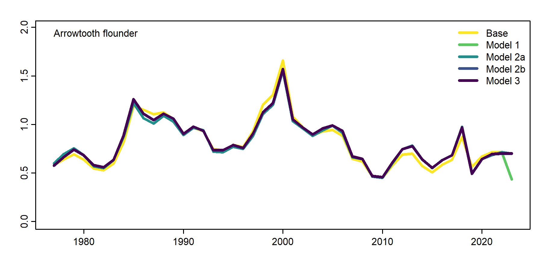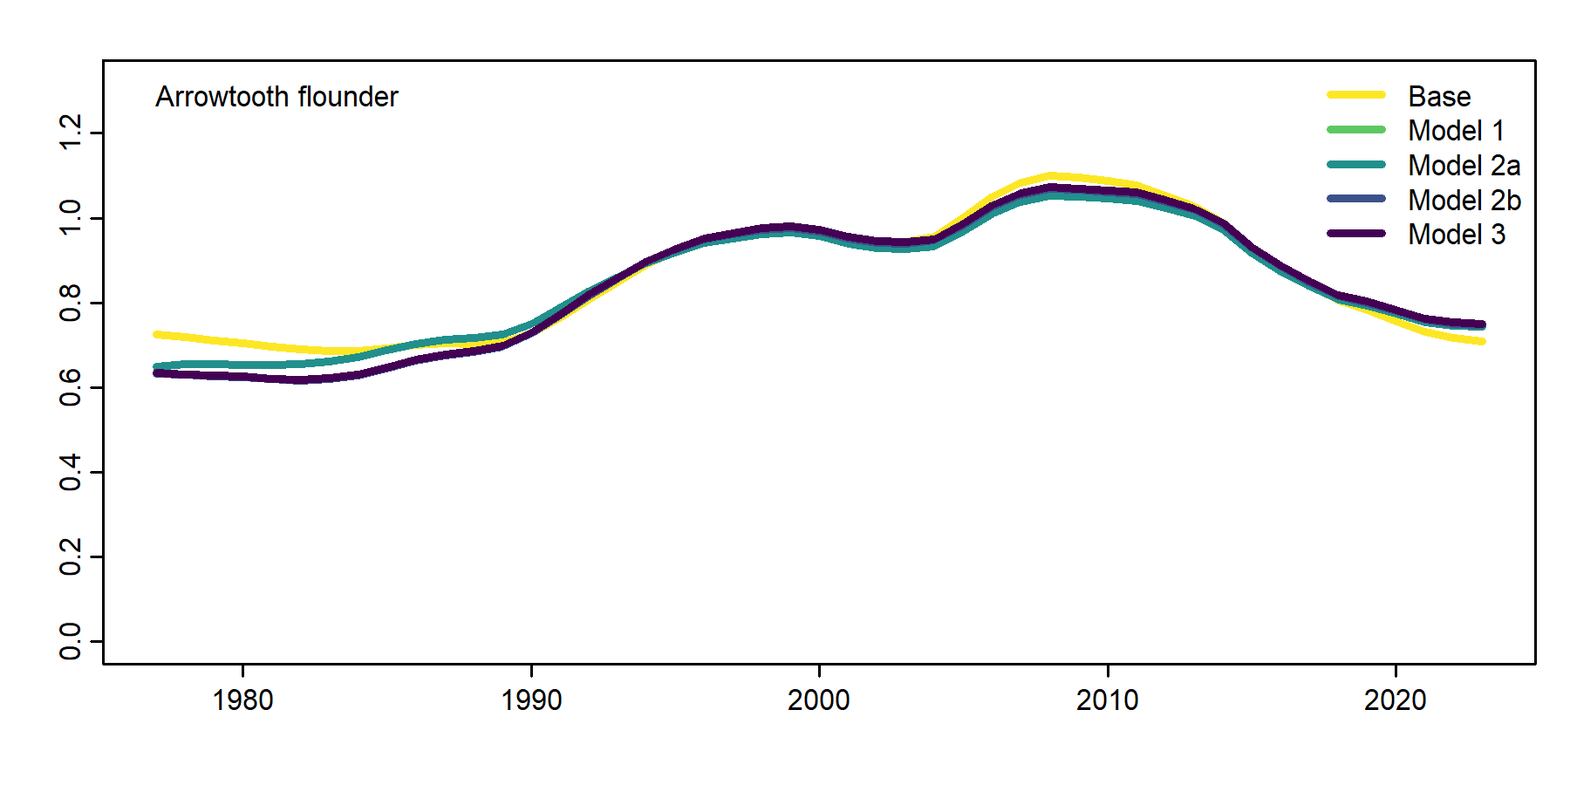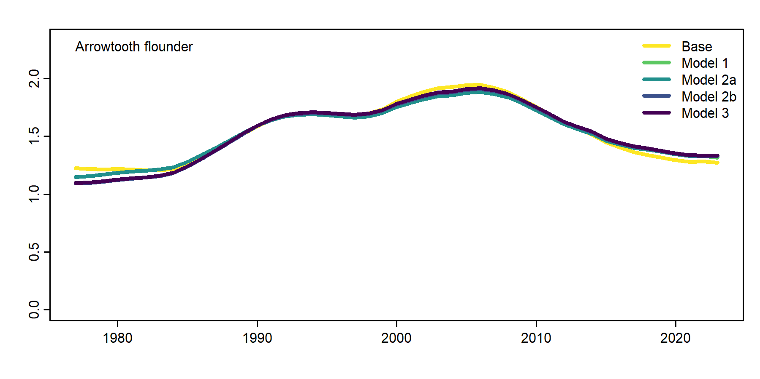

**Figure 2.** Time-series of estimated and projected age-1 recruitment (millions; top panel), SSB (million mt; middle panel), biomass (million mt; bottom panel) as determined from the CEATTLE single- and multi-species (cannibalism) models. Time-series under no fishing are indicated by the grey and black lines, respectively.

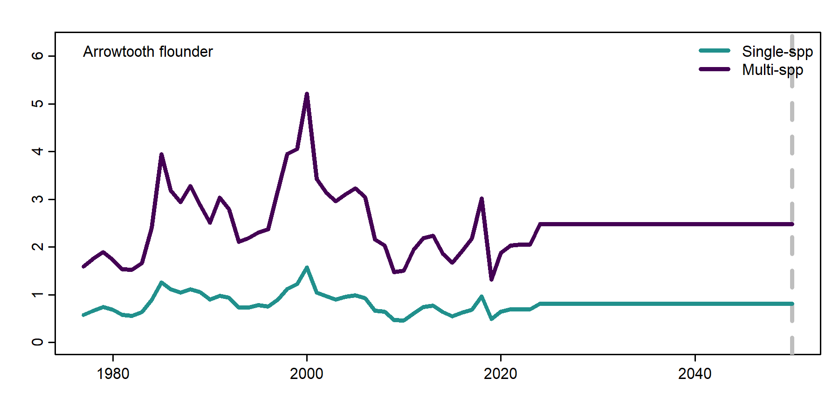

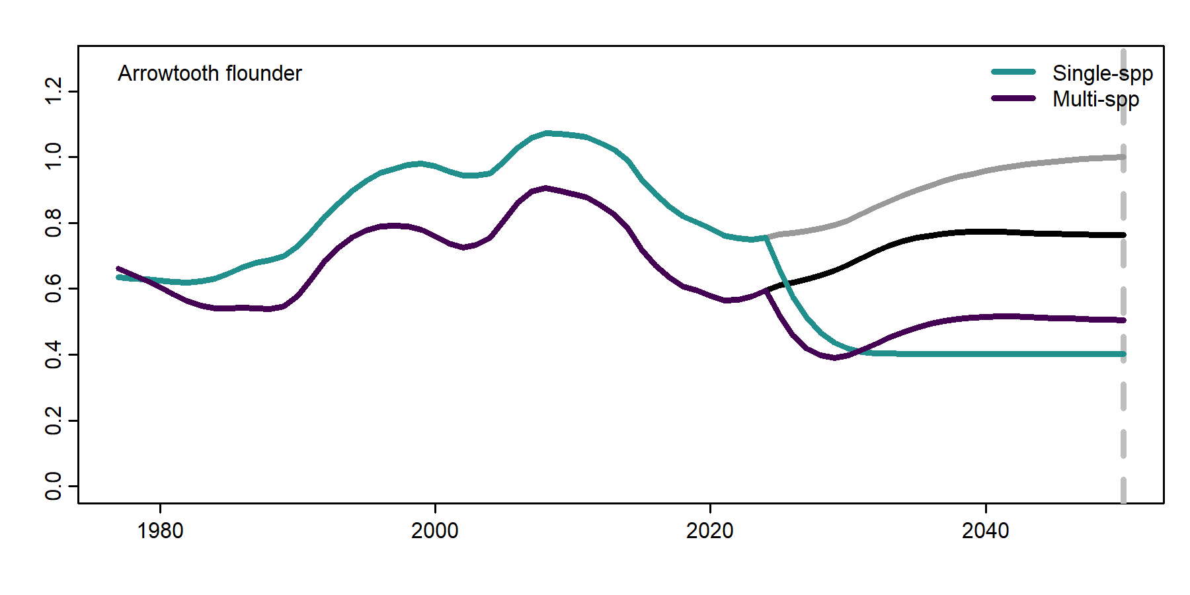

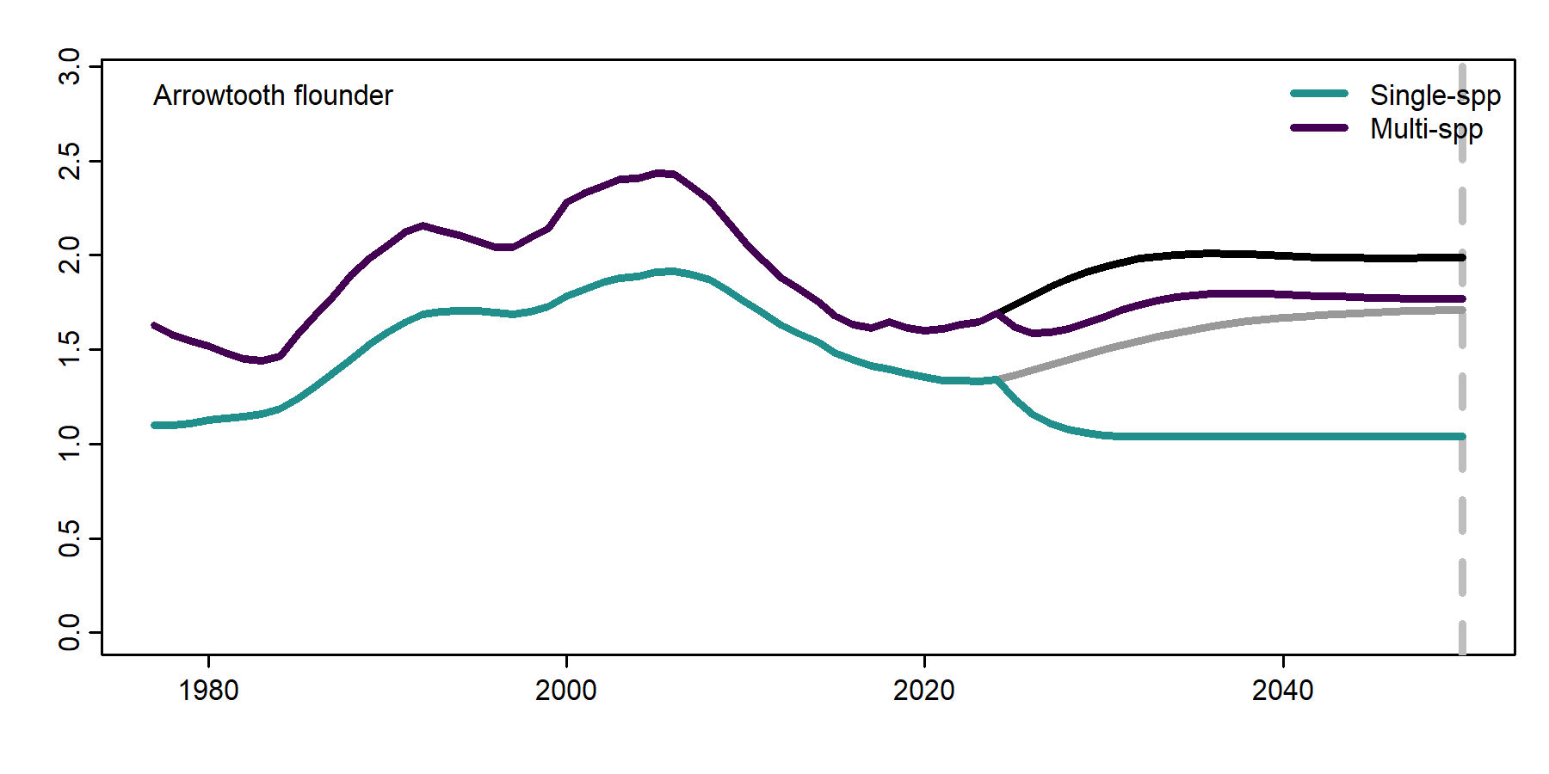

**Figure 3.** Time-series of estimated and projected catch (million mt) and biomass consumed as prey as determined from the CEATTLE single- and multi-species (cannibalism) models under Tier 3 fishing and no fishing (indicated by the grey and black lines).

